
Business Model Canvas (BMC)

Project: Integrated AI Cardiac Monitoring System

1. Customer Segments
- Primary Users: Cardiologists, hospitals, and cardiac surgery departments.
- Secondary Users: Post-surgery cardiac patients and their families.
- Institutional Stakeholders: Healthcare providers, research institutions, and insurance companies.

2. Value Proposition
- For Physicians: Intelligent, data-driven decision support through AI-based predictions.
- For Patients: Continuous, personalized monitoring improving safety and life quality.
- For Hospitals: Reduced emergency readmissions and optimized care management.
- For Siemens Healthineers: Expands the Connected Health portfolio with predictive, AI-driven monitoring.

3. Channels
- Integration within hospital IT systems.
- Secure, interactive web dashboard for real-time access.
- Wearable biometric sensors linked to cloud servers.
- Strategic partnerships with medical technology providers.

4. Customer Relationships
- Personalized technical and clinical support.
- Training sessions and workshops for doctors and medical staff.
- Real-time communication through notifications and reports.

5. Revenue Streams
- (For sustainability and potential scalability)
- Subscription model for hospitals and clinics.
- Bundled solutions with Siemens Healthineers medical devices.
- Research funding and innovation grants.
- SaaS model for predictive healthcare analytics.

6. Key Resources
- Technical: AI engine, cloud computing infrastructure, secured data storage.
- Human: Software engineers, data scientists, healthcare professionals.
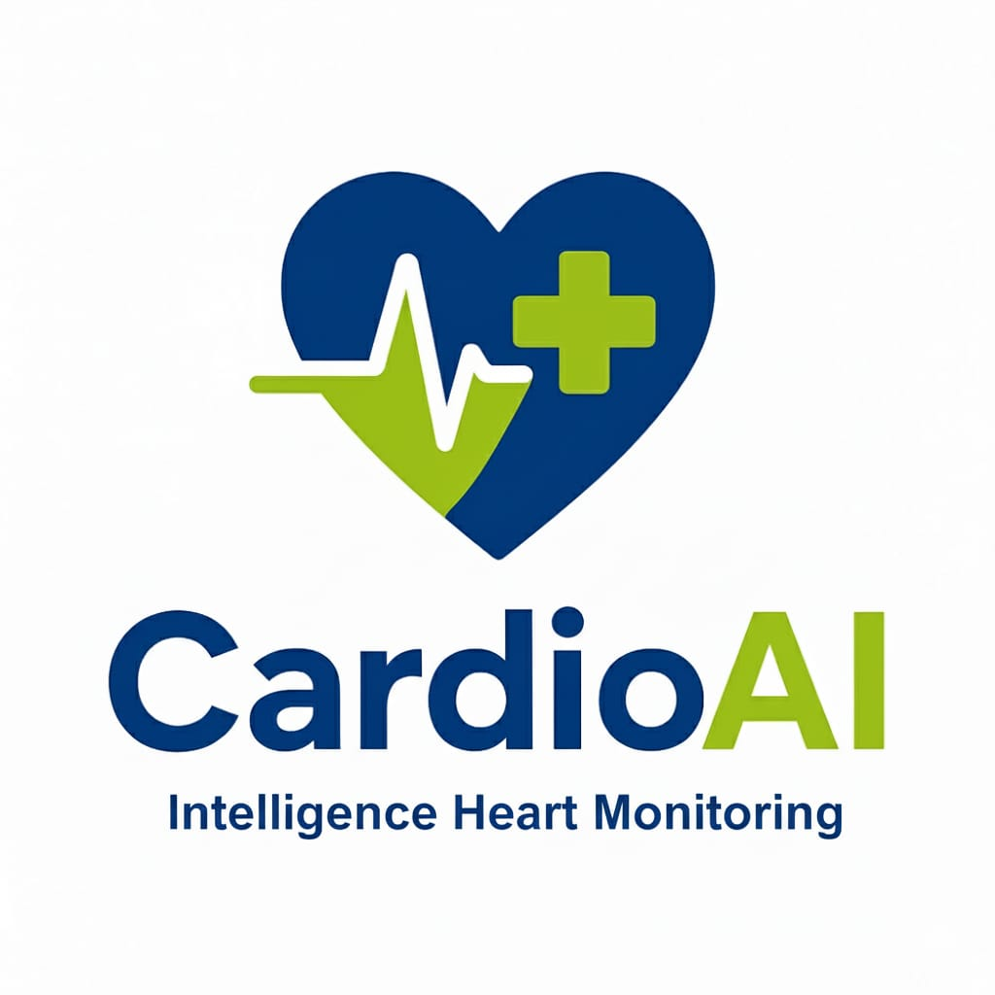
- Hardware: Heart rate, BP, temperature, and SpO₂ sensors.
- Partnerships: Siemens Healthineers, hospitals, and cloud providers.

7. Key Activities
- Designing and training predictive AI models.
- Integrating wearable devices with the monitoring platform.
- Ensuring security, privacy, and compliance (HIPAA/GDPR).
- Conducting pilot testing with hospitals.
- Updating and improving system performance continuously.

8. Key Partners
- Siemens Healthineers: Technology and integration partner.
- Hospitals / Cardiac Centers: For clinical trials and validation.
- Universities / Labs: AI development and algorithm optimization.
- Cloud Providers: Hosting and data scalability.

9. Cost Structure
- Development (AI models, hardware, software).
- Operational (servers, maintenance, data storage).
- Research and testing (clinical validation, feedback).
- Equipment procurement (sensors, devices).
- Cybersecurity and compliance costs.

Summary

The Integrated AI Cardiac Monitoring System transforms post-surgical care into an intelligent, proactive process. By combining real-time data, predictive AI analysis, and personalized patient modeling, it helps prevent cardiac complications before they occur — representing the next generation of precision healthcare.

